NAME: K Yamini
REG NO: 192572181

Write a Python program to solve the Missionaries and Cannibals problem using Breadth First Search (BFS).
Aim:
To safely transfer all missionaries and cannibals from one side of the river to the other without violating constraints.
Algorithm:
- Represent state as (M_left, C_left, Boat_position).
Boat_position = 1 (left), 0 (right)
- Initial state = (3, 3, 1)
- Goal state = (0, 0, 0)
- Use BFS with a queue.
- Maintain a visited list to avoid repetition.
- Generate all possible moves:
1 Missionary
2 Missionaries
1 Cannibal
2 Cannibals
- 1 Missionary + 1 Cannibal
- Check validity:
Missionaries ≥ Cannibals (on both sides)
Missionaries cannot be outnumbered
- Add valid states to queue.
- Repeat until goal state is reached.
- Print all steps with explanation.

Python Code:
from collections import deque
# Check if state is valid
def is_valid(m, c):
if m < 0 or c < 0 or m > 3 or c > 3:
return False
if m > 0 and m < c:
return False
if (3 - m) > 0 and (3 - m) < (3 - c):
return False
return True
# BFS solution
def solve():
start = (3, 3, 1)
goal = (0, 0, 0)
queue = deque()
visited = set()
queue.append((start, []))
while queue:
(m, c, b), path = queue.popleft()
if (m, c, b) in visited:
continue
visited.add((m, c, b))
path = path + [(m, c, b)]
if (m, c, b) == goal:
return path
# Possible moves
moves = [(1,0),(2,0),(0,1),(0,2),(1,1)]
for move in moves:
if b == 1: # Boat on left
new_state = (m - move[0], c - move[1], 0)
else: # Boat on right
new_state = (m + move[0], c + move[1], 1)
if is_valid(new_state[0], new_state[1]):
queue.append((new_state, path))
return None
# Solve
solution = solve()
# Output
print("Initial State: (3M, 3C, Boat Left)\n")
print("Steps:\n")
step = 1
for (m, c, b) in solution:
side = "Left" if b == 1 else "Right"
print("Step", step, ":", (m, c, "Boat on " + side))
# Comments in output
if step == 1:
print("# Start: All on left side")
elif step == 2:
print("# Move 2 Cannibals to right")
elif step == 3:
print("# Bring 1 Cannibal back")
elif step == 4:
print("# Move 2 Cannibals again")
elif step == 5:
print("# Bring 1 Cannibal back")
print()
step += 1
print("Goal Reached Successfully!")
Input:
Missionaries = 3
Cannibals = 3
Boat Capacity = 2

Output :
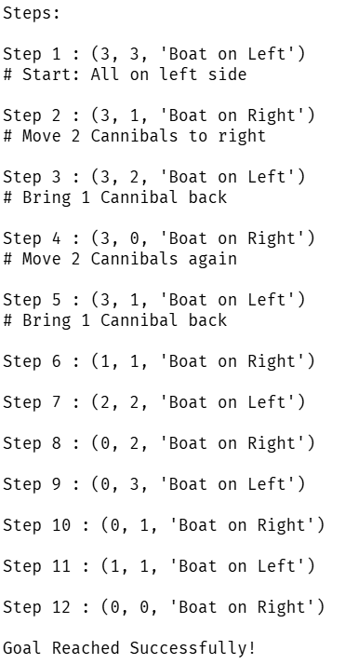
Result:
The Missionaries and Cannibals problem is solved successfully using BFS while maintaining all safety constraints.

